2 Weeks to go!
Information Bulletin #5
Wvfc07 will commence in just two weeks and Australia’s fencers are looking forward to welcoming you to Sydney.

Entries: are now posted on the web site: worldvets2007entries

Schedule/Start times
Day 1 Friday 14 September
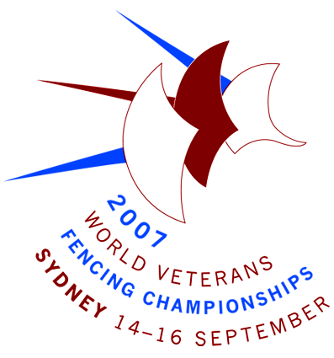
Foil Women Category A 8:30 am
Sabre Men Category A 8:50 am
Foil Men Category B 12:50 pm
Sabre Women Category B 1:10 pm

Day 2 Saturday 15 September
Epee Men Category A 8:30 am
Foil Women Category B 8:50 am
Epee Women Category A 11:50 am
Sabre Men Category B 12:50 pm

Day 3 Sunday 16 September
Epee Men Category B 8:30 am
Epee Women Category B 8:50 am
Sabre Women Category A 12:30 pm
Foil Men Category A 12:50 pm

Meeting Schedule
Thursday 13 September - The following meetings will take place at the venue:
09:00hrs – 11:00hrs: Directoire Technique
11:00hrs – 12:30hrs: Referees Meeting/ Réunion des Arbitres
14:00hrs – 15:30hrs: Heads of Delegations/ Réunion des chefs de délégations
16:00hrs: Composition of Pools 14 September.

Equipment Control – at Venue

Events | Submit Day/Time |  | Collect Day/Time
Day 1  WF Category A  MS Category A  MF Category B  WS Category B | Thur 13th Sept  12:00-14:00hrs |  | Thur 13th Sept  18:00–19:30 hrs  Fri 14th Sept 7:30- 8:30 hrs
Day 2  ME Category A  WE Category A  WF Category B  MS Category B | Fri 14th Sept  9:30–12:00 hrs |  | Fri 14th Sept  18.00 – 20:30 hrs  Sat 15th Sept  7:30- 8:30 hrs
Day 3  WE Category B  ME Category B  MF Category A  WS Category A | Sat 15th Sept  9:30-12:00 hrs |  | Sat 15th Sept  18:00-20:30 hrs  Sun 16th Sept  7:30- 8:30 hrs
The number of articles handed to the Checking Centre for each event is limited per fencer to:  - Four weapons  - Four bodywires |  | - Two cloves/cuffs  - Two conductive jackets  - Two masks  - Three mask-to-jacket leads  - 1 jacket for épée

Registration
To manage volume and minimise delays large Delegations are requested to make an appointment for registration of Athletes, Referees and Officials.
Contact Event Services Director – Andrew Ius - Email: aff_secgen@hotmail.com
Mobile: Within Australia 0419 313 231 Outside Australia 61 + 419 313 231

At registration the following are required:
- Passport
- Libération de Responsabilité/Discharge Of Responsibility
- Medical Certificate
- Payment for entry fees
- Payment for reserved dinner tickets
- Payments for referees provided under arrangement with Australian Fencing.

Registrations are accepted on:
12th September at venue – for all events (by appointment)
Hours: 14:00 - 18:00 hrs

13th September at venue – for all events
Hours: 08:30 - 13:00 hrs & 14:00 - 18:00 hrs

14th September at venue – for 15 September events
Hours: 08:30 - 18:00 hrs

15th September at venue – for 16 September events
Hours: 08:30 - 18:00 hrs.

NOTE: Accreditation will be issued on registration. Accreditation is required for venue entry or a ticket will be required.

Championship Dinner and Dancing
The Championship dinner will be held in the ballroom, Novotel Sydney Olympic Park (the event hotel). Limited tickets remain. Reserve & pay at registration to ensure your place.

Uniforms
You are reminded that the requirement for the fencer’s Name and the Three-Letter Country Code on jackets/lamés is mandatory.
ITEM Clothing RULE m.25
The name of the fencer must be displayed on the back of the jacket, with the abbreviation of the national federation below it, at the level of the shoulder blades.
They must be printed directly onto the jacket or onto a cloth carefully sewn onto the jacket.
There will be a service in Sydney where this can be printed at nominal cost by prior arrangement with the organisers. Email immediately: deploy@tpg.com.au

Transport to Sydney Olympic Park
If you are not staying at the event Hotels, a short walk to the event venue, you are reminded that Sydney Olympic Park is a busy sporting complex. Please allow ample time to travel to the venue for your event.
A transport guide is available on the Sydney Olympic Park website, at http://www.sydneyolympicpark.com.au/Visiting/transport.

Get Familiar with Sydney
Sydney Weather
Sydney News

See you very soon!

Bill Ronald
Event Director
31 August 2007

