
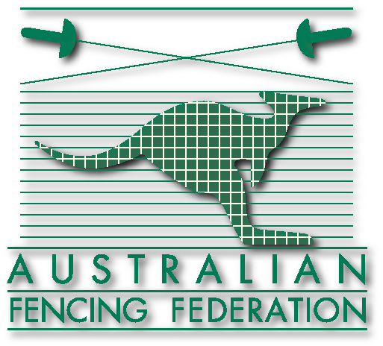



Challenge Australia 2011
FIE - FEDERATION INTERNATIONALE D’ESCRIME

Women's World Cup Epee, Women’s World Cup Epee Teams
See the world’s best fencers up close, in action –
All vying for London Olympic Selection!
Volunteer!

You will be part of a dynamic team and will get training & practice in scoring/timing scoreboard operation - event management and the role modelling experience of seeing the world's very best fencers in International action. . .

The Badgery Pavilion & Howie Complex

Sydney Showground, Sydney Olympic Park

Friday 24 June 10:00 hrs – 17:00 hrs
- Women’s Individual Competition 2 rounds of Poules + preliminary D/E

Saturday 25 June – 9:00 hrs to 17:30 hrs
- Women's Competition D/E of 64
- Semi-finals and GOLD MEDAL matches
Sunday 26 June – 9:00 hrs to 18:00 hrs
- Women's Team Competition D/E of 32 (Final 17:00 hrs)

You will be 13+ years of age. You will be provided with:
An event T-shirt, lunches & drinks, and an AFF certificate of completion.
Training in event scoring and timing with notes.
+ A Guest Ticket to the final session on Sunday

Interested? Contact the Event. Director – now!
Bill Ronald Event Director | director@challengeaus11.org
Bill Ronald Event Director | Mob: 0403 267 330 Fax: (02) 9874 6168
For logistics reasons preference must be given to volunteers who can work 3 days of Challenge 2011
For full event details and to download the volunteer registration form:
Visit: http://challengeaus11.org
proudly supported by


J G
Fencing

Volunteers aged 13 -18 must provide permission from Parent or Guardian

